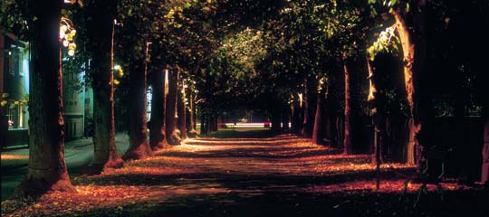
A step into the future
Alingsås – a symbol of the upturn in everyday lighting design in small European towns
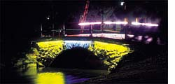
If Astrid Lindgren, world-famous author of children's books with heroes and heroines such Karlsson and Pippi Long Stocking, was ever to think about writing another novel, Alingsås would make the perfect setting. Alingsås is a typical small Swedish town with approx. 35,000 inhabitants situated on the main traffic route (road and rail) be-tween Stockholm and Gothenburg, which is just 30 kilometres away. Many people living in Alingsås work in Gothenburg.
The town officially became a municipality in 1690, but there are records of it dating back to 1357. The urban design is marked by historic wooden architecture. In the old centre some of the buildings are up to 350 years old. Alingsås has already won a prize in Sweden for the best kept historical centre.
Within Sweden Alingsås is known as the birthplace of Jonas Alströmer, who was the first to plant potatoes in Sweden. There is a Potato Festival in Alingsås every June, which attracts many visitors (former inhabitants and friends of the town). The last festival recorded 125,000 visitors, which is incredible for a town of Alingsås' size.
The image of the town is one of cosiness and social life. Numerous cafes line the streets in the old part of town and people say that Alingsås has the most cafes per head in the whole of Sweden. Alingsås is not (yet) an industrial location. Apart from developing industrial sites, tourism is another area which is being expanded. The town is also looking to increase the number of inhabitants and to gain in significance culturally speaking. The local government officials and the Alingsås tourist office see light as a means of creating an unusual and attractive event, but in fact they discovered the power of light almost by chance.
In 1998 and 1999 the town collaborated with the Ljuszentrum in Gothenburg to have a few loca-tions in Alingsås illuminated. The Ljuscentrum no longer exists, but in those days the centre approached Alingsås town council and asked if it would be possible to use the town as a location for a lighting workshop. Kjell Hult, Administra-tive Director of Alingsås, reported that after each of the workshops that took place there the inhabitants of Alingsås were always disappointed when the lighting installations were taken away. The town council was, therefore under considerable pressure to stage a repeat lighting event in October 2000, this time in full collaboration with ELDA.
The overall theme of the event was "What is a lighting masterplan? Do towns need them?" The individual projects designed by the workshop groups were therefore distributed through the town. One group worked on two locations, an old water mill and a small park, and re-connected the two with light during their workshop. Another group worked on seven completely different bridges that cross the river running through the town. Other projects were St. Christine's church, a section of a long avenue that borders the centre of town to the north, an exciting rockface, and an old Italian-style villa in the grounds of a large park. The villa is interesting architecturally speak-ing, but is so different from the other architecture in the town that it appears to have no real connection to the rest of the built environment.
The workshop was rounded off by an international conference on the theme of urban lighting strategies with an historical portrait of lighting in towns and cities (Jan Garnert, Sweden), a report on the experiences gathered by the city planning department of Malmö/S (Pekka Kärppä) and by the town council and the lighting design team working together on the lighting masterplan of Coventry/UK (Andy Telford, Mark Major, and Steve Power). The subsequent round table discussion showed that the exchange of ideas among international lighting designers and experts from the lighting field could well lead to the rapid development of urban lighting programmes.
After the first week with the ELDA workshop, Alingsås staged a series of other design events on traditional industrial design, computer graphics and general urban planning.
With all the lighting design activities going on, the town underwent some interesting changes that were not only brought about by the workshop crews. One day after the installations were officially open for the public the inhabitants of Alingsås started placing little lights in their front gardens, some of them even with colour filters: the whole town was fascinated by the power of lighting design.

